 **VELAMMAL BODHI CAMPUS**

**GRAND TEST – III**

**Grade: X (FOUNDATION) Time: 3hours**

**Subject: Mathematics Marks: 80**

1. **This Question Paper has 5 Sections A-E.**
2. **Section A has 20 MCQs carrying 1 mark each**
3. **Section B has 5 questions carrying 02 marks each.**
4. **Section C has 6 questions carrying 03 marks each.**
5. **Section D has 4 questions carrying 05 marks each.**
6. **Section E has 3 case based integrated units of assessment (04 marks each) with sub-parts of the values of 1, 1 and 2 marks each respectively.**
7. **All Questions are compulsory. However, an internal choice in 2 Qs of 5 marks, 2 Qs of 3 marks and 2 Questions of 2 marks has been provided. An internal choice has been provided in the 2 marks questions of Section E**
8. **Draw neat figures wherever required. Take π =22/7 wherever required if not stated.**

**SECTION – A 20 $×1=20$**

1. The sum of three non -zero prime number is 100. One of them exceeds the other by 36.Find the largest number.
2. 73 b) 91 c) 67 d) 57
3. The sum of the factors of 24 is
4. 80 b) 90 c) 60 d) 85
5. If 3 is a zero of the polynomial ${9x}^{2}-3\left(a-1\right)x+5$, then the value of $a$ is
6. $\frac{80}{9}$ b) $\frac{40}{9}$ c) $\frac{95}{9}$ d) $\frac{94}{9}$
7. If the sum of the square of the zeroes of the polynomial $p\left(x\right)=x^{2}+7x+k$ is 25 then $k=$
8. 12 b) – 12 c) -24 d) 49
9. If the last term of the A.P.12, 15, 18, … is 99, then the number of terms of the A.P is
10. 20 b) 30 c) 35 d) 40
11. In triangle ABC, $∠B={90}^{0}$ and BD $⊥$ AC then BD2
12. ADAC b) CD $×$ AC c) AD $×$ DC d) AB $×$ BC
13. If the radii of two concentric circles are 3 cm and 5 cm then the length of the chord of one circle which is tangent to the other circle is
14. 4 cm b) 8 cm c) 10 cm d) 6 cm
15. In the figure PA and PB are tangents to the circle with centre O. If ∠APB = 60°, then ∠OAB is

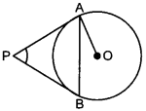

1. 150 b) 300 c) 600 d) 450
2. The ratio in which the point P(1, 2) divides the join of A($-$ 2, 1) and B(7, 4) is
3. 3 : 2 b) 2 : 3 c) 2 : 1 d) 1 : 2
4. A number is selected from the numbers 1, 2, 3, 4, …………….25. The probability that the number selected is a multiple of 4 is
5. $\frac{4}{25}$ b) $\frac{5}{25}$ c) $\frac{6}{25}$ d) $\frac{7}{25}$
6. The mode of the given data is

|  |  |  |  |  |  |  |  |  |
| --- | --- | --- | --- | --- | --- | --- | --- | --- |
| Age | 0 – 6 | 6 – 12 | 12 – 18 | 18 – 24 | 24 – 30 | 30 – 36 | 36 – 42 | 42 - 48 |
| Frequency | 6 | 11 | 25 | 35 | 18 | 12 | 6 | 4 |

1. 20.22 b) 19.47 c) 21.12 d) 20.14
2. If the circumference of a circle exceeds its diameter by 30 cm, then the radius of the circle is
3. 7 cm b) 4 cm c) 6 cm d) 8 cm
4. The maximum volume of a cone that can be carved out of a solid hemisphere of radius $r$ is
5. $\frac{πr^{2}}{3}$ cubic units b) $\frac{πr^{3}}{3}$ cubic units c) $\frac{πr^{3}}{4}$ cubic units d) $\frac{πr^{2}}{4}$ cubic units
6. If $\sec{θ}+\tan{θ}=p$ then $\cos{θ=}$
7. $\frac{p^{2}+1}{2p}$ b) $\frac{p^{2}+1}{p}$ c) $\frac{2p}{p^{2}+1}$ d) $\frac{2p}{p^{2}-1}$
8. The angle of elevation of the top of a tower from a point on the ground 30 m away from the foot is 300. The height of the tower is
9. 30 m b) 10 m c) 10 $\sqrt{3}$ m d) 30 $\sqrt{3}$ m
10. The probability of getting 53 Fridays in a leap year is
11. $\frac{1}{7}$ b) $\frac{2}{7}$ c) $\frac{3}{7}$ d) $\frac{5}{7}$
12. **Statement A (Assertion):** The area of a quadrant circle whose radius 10.5 cm is 86.625 cm2.

**Statement R (Reason)**: Length of arc of a sector is $\frac{θ}{{360}^{0}}×2πr.$

(a) Both assertion (A) and reason (R) are true and reason (R) is the correct explanation of assertion (A)

(b) Both assertion (A) and reason (R) are true and reason (R) is not the correct explanation of assertion (A)

(c) Assertion (A) is true but reason (R) is false.

(d) Assertion (A) is false but reason (R) is true.

1. If two positive integers a and b are written as a = x3y2 and b = xy3; x, y are prime numbers, then HCF (a, b) is

(a) xy (b) xy2 (c) x3y3 (d) x2y2

1. **Statement A (Assertion):** The distance between the points (4, p) and (1, 0) is 5, then the value of p is $±4.$

**Statement R(Reason)**: The distance of line segment joining the points A( $x_{1},y_{1})$ and B $(x_{2},y_{2})$ is $\left(\frac{x_{1}+x_{2}}{2},\frac{y_{1}+y_{2}}{2}\right)$

(a) Both assertion (A) and reason (R) are true and reason (R) is the correct explanation of assertion (A)

(b) Both assertion (A) and reason (R) are true and reason (R) is not the correct explanation of assertion (A)

(c) Assertion (A) is true but reason (R) is false.

(d) Assertion (A) is false but reason (R) is true.

20. If 3cm,4cm,5cm are the sides of a right angled triangle,if r is the radius of a circle which touches the sides of the triangle.Then the radius of the circle(in cm) is

(a)1 (b)2 (c)3 (d) none of these

**SECTION – B 5 $×2=10$**

21 **.**If the pair of linear equations $2x+3y=11$ and $\left(m+n\right)x+\left(2m-n\right)y=33$ has infinitely many solutions, then find the values of $m$ and $n.$

22.In the given figure, if AB⊥BC and DE⊥AC. Prove that  ΔABC ~  ΔAED.



23**.** In the given figure, a circle is inscribed in a triangle ABC in which AB = AC, prove that BE = EC



24.In a circle of radius 21 cm, an arc subtends an angle of 60∘ at the centre. Find

(i) the length of the arc and

(ii) area of the sector formed by the arc.

25. Prove that $\frac{\sin{θ-2\sin^{3}{θ}}}{2\cos^{3}{θ}-\cos{θ}}=\tan{θ}$

OR

If $\tan\left(A+B\right)=\sqrt{3}$ and $\tan\left(A-B\right)=\frac{1}{\sqrt{3}}$ then find A and B.

**SECTION – C 6**

26. Prove that $\sqrt{7}$ is an irrational number, hence prove that $9+2\sqrt{7}$ is an irrational number.

27. If and are the zeroes of the polynomial $x^{2}+2x-15,$ then form a quadratic equation whose zeroes are 2α+ β and α+2β.

28. In a class, if three students sit on each bench, one student will be left. If four students sit on each bench, one bench will be left. Find the number of students and the number of benches in the class.

OR

From a bus stand Redhills in Chennai, if we buy 2 tickets to Ponneri and 3 tickets to Madhavaram the total cost is ₹ 46 but if we buy 3 tickets to Ponneri and 5 tickets to Madhavaram, the total cost is ₹ 74. Find the fares from Redhills to Ponneri and Madhavaram.

29. If tanA= n tanB and sinA=m sinB , prove that cos2A=(m2-1)/(n2-1)

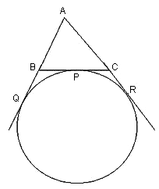 30.A circle is touching the side BC of ΔABC at P and touching AB and AC produced at Q and R respectively. Prove that AQ=1/2 (perimeter of triangle ABC)

OR

From an external point P, a tangent PT and a line segment PAB is drawn to a circle with centre O. ON is perpendicular on the chord AB. Prove that PA. PBPT2.

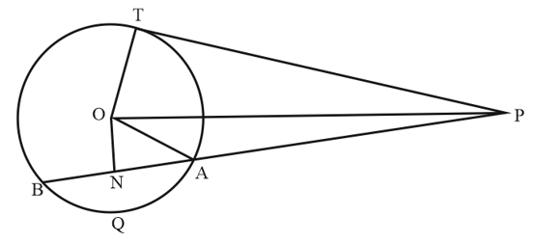

31. Two coins are tossed simultaneously. What is the probability of getting

1. At least one tail?
2. At most one head?
3. A head and a tail?

**SECTION – D 4 $×5=20$**

32.A train travels at a certain average speed for a distance 63 km and then travels a distance of 72 km at an average speed of 6 km/hr more than the original speed. If it takes 3 hours to complete total journey, what is its original average speed?

OR

In a flight of 600 km, an aircraft was slowed down due to bad weather. Its average speed for the trip was reduced by 200 km/hr from its usual speed and the time of the flight increased by 30 min. Find the scheduled duration of the flight.

33.(i)State and prove Basic proportionality theorem. (3M)

(ii) In a ΔABC, D and E are points on the sides AB and AC respectively such that

DE || BC. If AD = 4x – 3, AE = 8x – 7, BD = 3x – 1 and CE = 5x – 3,

find the value of x. (2M)

34. From a solid right circular cylinder with height 10 cm and radius of the base 6 cm, a right circular cone of the same height and same base is removed. Find the volume of the remaining solid.Also, find the whole surface area.

OR

A cylindrical container of radius 6 cm and height 15 cm is filled with ice-cream. The whole ice-cream has to be distributed to 10 children in equal cones with hemispherical tops. If the height of the conical portion is four times the radius of its base, find the radius of the ice-cream cone.

35. Find the mean and mode of the following frequency distribution and find median by empirical relationship.

|  |  |  |  |  |  |  |
| --- | --- | --- | --- | --- | --- | --- |
| Class Interval | 25 – 30 | 30 – 35 | 35 – 40 | 40 – 45 | 45 – 50 | 50 – 55 |
| Frequency | 25 | 34 | 50 | 42 | 38 | 14 |

**SECTION – E 3**

36. Students of Velammal Bodhi Campus, Ponneri are standing in rows and columns in their playground for a drill practice. A, B, C and D are the positions of four students as shown in the figure.

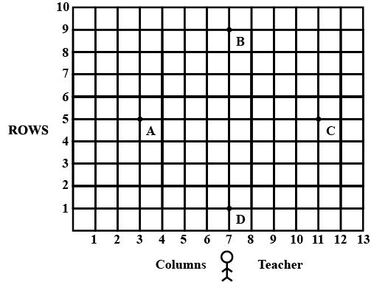



1. Find the coordinates of the mid-point of AB. (1 M)
2. Find the distance between C and D. (1M)
3. Find the coordinate of the point which divides AB in the ratio 2 : 1. (2 M)

OR

Show that the diagonals of the quadrilateral formed by joining A, B, C and D in order bisect each other.

37. Suresh wants to buy a car and plants to take loan from a bank for his car. He repays his total loan of ₹ 1,18,000 by paying every month starting with the first instalment of ₹ 1000. If he increases the instalment by ₹ 100 every month.

1. What is the amount paid by him in 30th instalment? (2 M)

OR

What is the total amount paid by him in 30 instalments?

1. What amount does he still have to pay after 30instalments? (1 M)
2. If total instalments are 40, then what amount was paid in the last instalment? (1 M)

38. A man on a cliff observes a boat at an angle of depression of 300 which is approaching the shore to the point immediately beneath the observer with a uniform speed. Six minutes later, the angle of depression of the boat is found to be 600.

1. Draw a neat labelled figure to show the above situation diagrammatically. (1M)
2. Find the time taken by the boat to reach the shore from beginning. (2 M)

OR

If the height of the cliff is 20 m, then find the distance between two positions of the boat.

1. If the distance between the base of the cliff and the boat is 12 m, when the angle of depression is 600, then find the height of the cliff. (1 M)